# Invoice Application

## Client Requirements

The client has requested a prototype Invoice application that will perform the following functions

It must record Customer details and Invoice details.

The customer details to be recorded are:

* Customer Number
* Customer Name,
* Address,
* Invoice number
* Contact number

The Invoice details to be recorded are:

* Invoice Number
* Customer Number
* Description
* Costs
* Payment Date

## Prototype description

**How to create new customers**

To add a new customer, enter a name and address in the fields under the Customer List then click add.

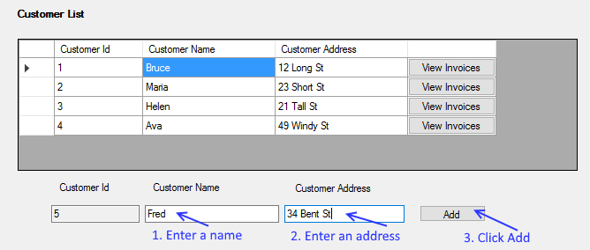

The new customer then appears in the list and the text boxes are cleared for the next customer to be added.

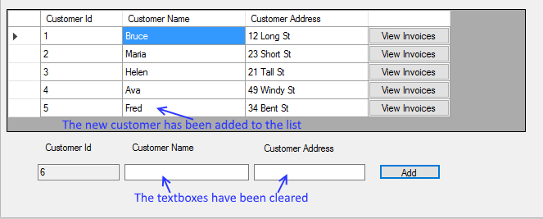

**How to add a new invoice**

To add a new invoice, select the customer you want to add an invoice to by clicking the associated View Invoices button. This will show the invoices for the associated customer. Then you want to add a description of the invoice the cost of the invoice and the payment date which is already set two weeks in advance of today.

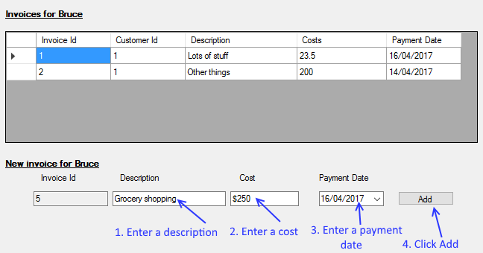

The new invoice then appears in the list and the text boxes are cleared for the next invoice to be added.

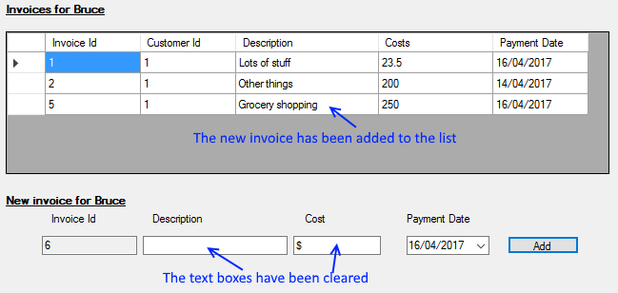

## What is object-oriented programming?

Object-oriented programming (OOP) refers to a type of computer programming (software design) in which programmers define not only the data type of a data structure, but also the types of operations (functions) that can be applied to the data structure.

In this way, the data structure becomes an object that includes both data and functions. In addition, programmers can create relationships between one object and another. For example, objects can inherit characteristics from other objects.

(<http://www.webopedia.com/TERM/O/object_oriented_programming_OOP.html>)

## What is one open-source development tool?

Node.js is a open-source development tool.

([http://www.infoworld.com/article/2982920/open-source-tools/bossie-awards-2015-the-best-open-source-application-development-tools.html#slide3](http://www.infoworld.com/article/2982920/open-source-tools/bossie-awards-2015-the-best-open-source-application-development-tools.html%23slide3))

## Describe the process of small-size application development

The process of small size app development is

1. Requirement gathering and analysis
2. System analysis
3. System design
4. Coding
5. Testing
6. Implementation